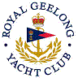 | Royal Geelong Yacht Club Inc.  Est 1859
Trophy Deed of Gift.

Trophy: | Lou Abrahams Memorial Trophy
Presented by:
Date: | 2015
For: | IRC Overall Passage Race Winner ~ FoS Regatta
Remarks / Revisions
Click HERE for a List of Recipients

